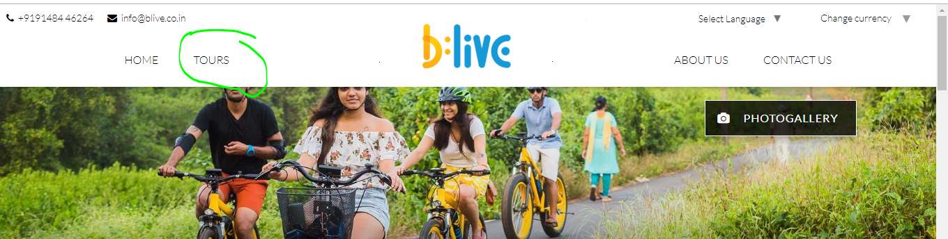
Create Drop Down Menu (all tours)
Menu bar fix when scroll down
Add one Testimonials Page
Add one pages for video
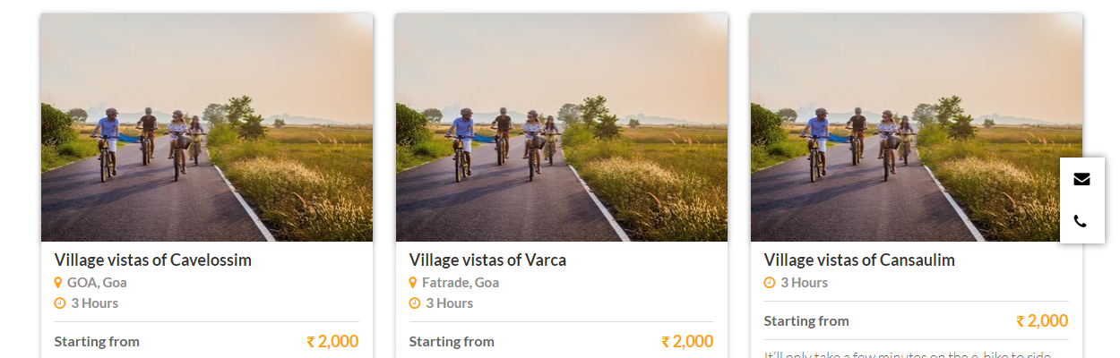
Upload different images for each tour
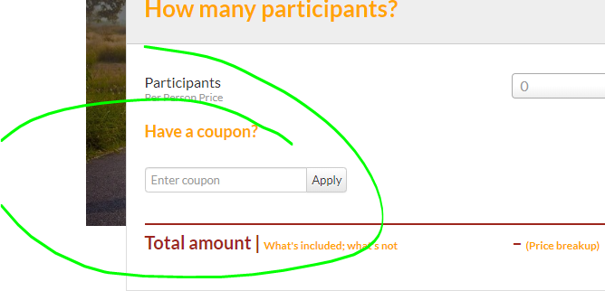
Please show all coupon code
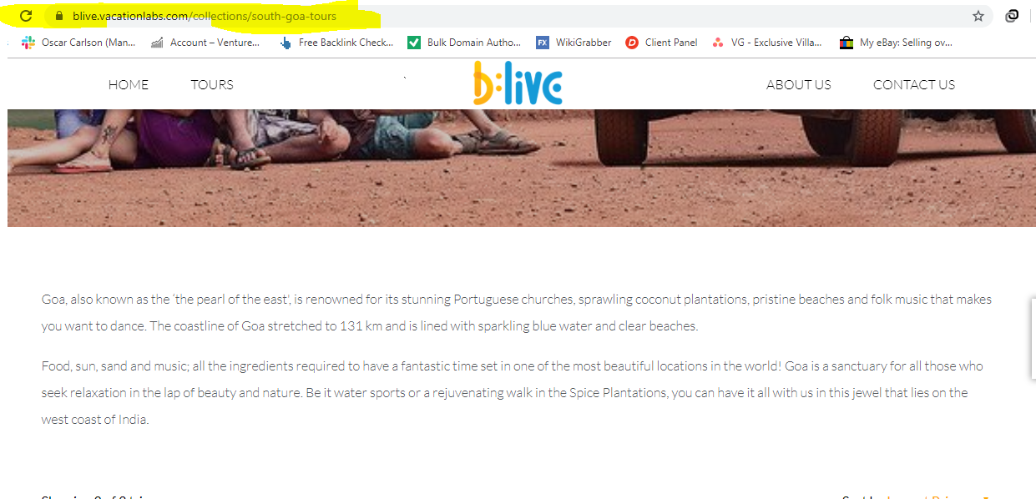
Add more content
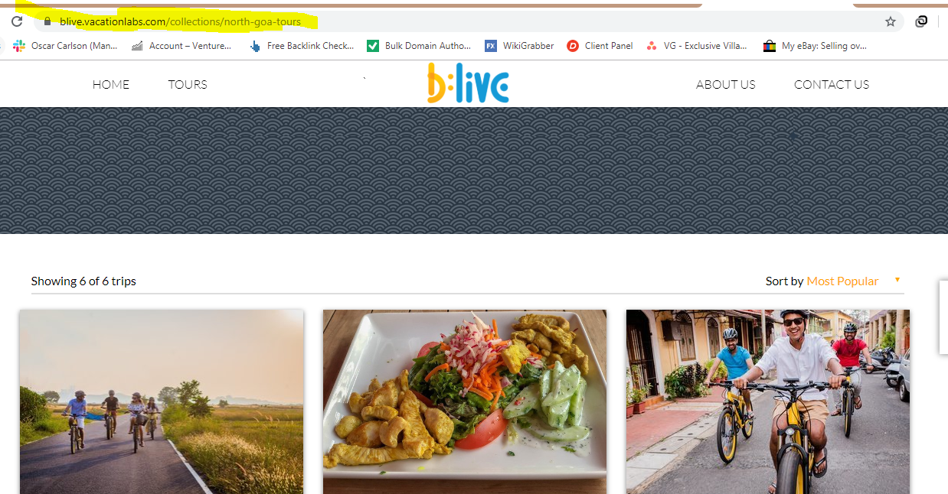
Add more content

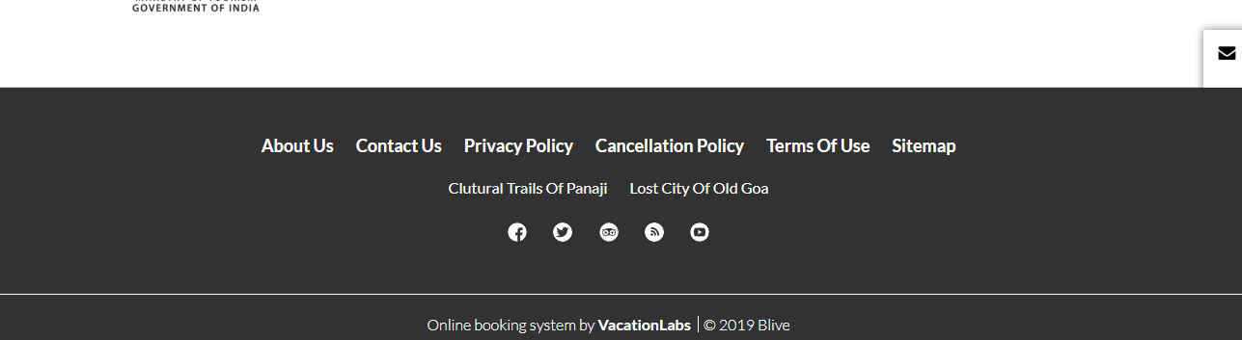
Add tours pages in footer
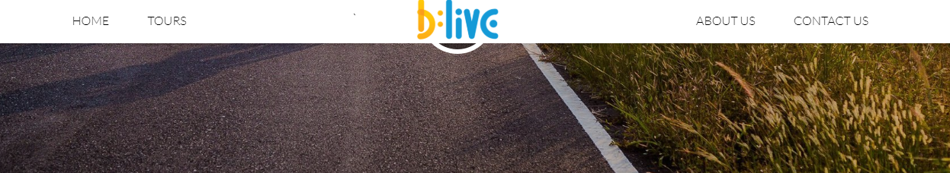in menu please add South Goa Tours and north Goa Tours pages

